**Linux Administration**

**Assignment-1**

* **Taking**

**Name : Praveen Kumar**

**Blood: B+**

**As example.**

* **Create a blank file named "myfile".**

Command >> **touch myfile**



* **Open "myfile" in vi editor.**

Command >> **vi myfile**

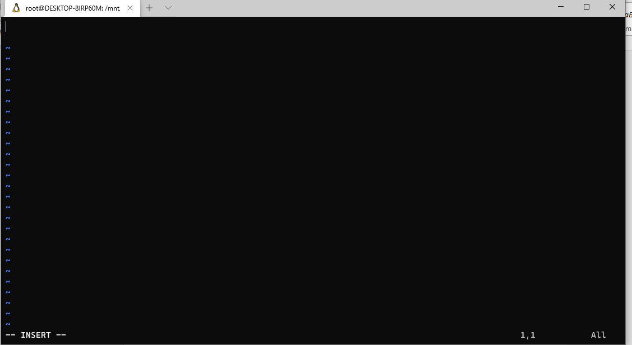

* **Write your name, address, email id, phone number and blood group in 5 different lines.**

Commands >> **i 🡪** to insert

**Esc 🡪**to exit from insert mode

**:wq 🡪** to write and quit

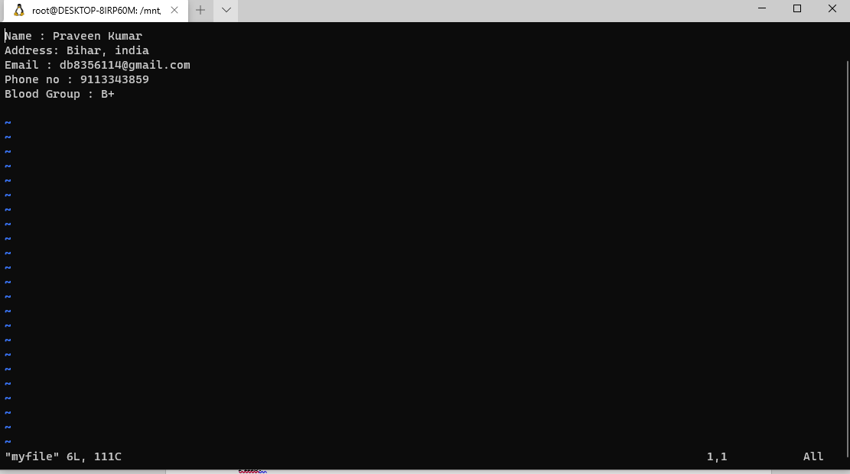

* **Build one single expression to see the line with your name and blood group in myfile.**

Command >> grep -E 'Name|Blood' myfile

